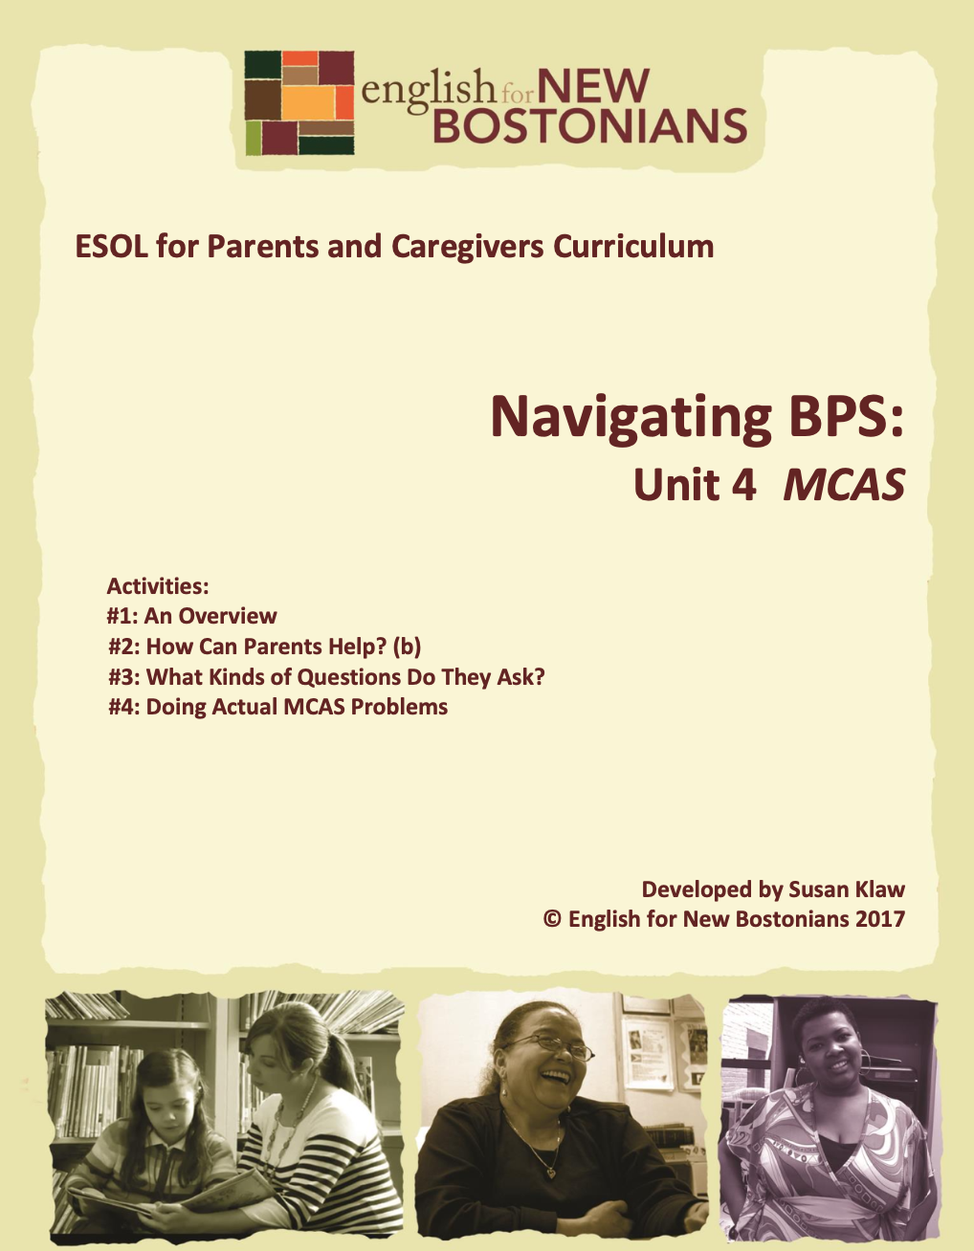About English for New Bostonians
English for New Bostonians (ENB) invests in the future of our region by fostering a high-quality ESOL system that prepares immigrants to pursue their educational, economic and civic aspirations. Through grant making, training teachers, and building public awareness, ENB expands the number of English for Speakers of Other Languages (ESOL) seats, improves program quality across agencies, customizes curricula to diverse subpopulations, and leverages private and public resources. Founded in 2001 by the Mayor’s Office for Immigrant Advancement (MOIA), immigrant leaders, and local foundations, ENB now involves several city departments, approximately 20 public and private funders, and numerous community organizations.

About the ESOL for Parents and Caregivers Initiative
Through ESOL for Parents and Caregivers, ENB guides ESOL providers and immigrant-rich schools in building partnerships to facilitate parent engagement in schools, enabling parents/caregivers to improve their English and digital literacy skills, navigate school systems, and understand expectations and opportunities for school involvement and ways to optimize children’s learning. At the same time, ESOL for Parents helps adults prepare to pursue their own educational and employment goals, while supporting children’s learning – aiming to eliminate multigenerational poverty.

About Susan Klaw
Susan Klaw has directed, taught in, and developed original curriculum materials for Boston-based parent ESOL programs since 1991. She has delivered extensive training locally and nationally on various aspects of Family Literacy and been named a “Literacy Champion” by the Massachusetts Literacy Foundation, Parent Educator of the Year by the Children’s Trust Fund, and Adult Educator of the Year by the Massachusetts Coalition for Adult Education.

About the ESOL for Parents and Caregivers Curriculum
The Curriculum (on ENB website and available free of charge) gives ESOL teachers background materials, lessons and activities designed to help immigrant parents learn English and become more effectively involved in their children’s education. Selecting curriculum units and lessons relevant to their classes, ESOL teachers can orient immigrant parents to the U.S. school system and provide practical skills such as interpreting report cards, participating in teacher conferences, advocating for children, and supporting children's learning at home. While some information is Boston specific, much can be used in any locale. ENB can assist in adapting materials for school districts. Additionally, ENB offers a Companion Middle/High School Guide, as well as a Digital Learning Guide to support online instruction.

Using the ESOL for Parents and Caregivers Curriculum
All materials are intended to be downloaded and widely used. Please cite English for New Bostonians and credit English for New Bostonians on all reproductions. We welcome feedback and stories on how you and your students are using the ESOL for Parents and Caregivers Curriculum!

Thanks to the many public and private funders that have supported this project, especially the Highland Street Foundation, Shipley Foundation, Hamilton Foundation, Moses Kimball Foundation, Plymouth Rock Foundation, Blum Shapiro Foundation and the Mayor’s Office for Immigrant Advancement’s We Are Boston Gala.

Contact us at info@englishfornewbostonians.org
or visit us online at www.englishfornewbostonians.org

MCAS: Topic 1 Unit 4 Page 2 ©English for New Bostonians 2017

ACTIVITY #1: AN OVERVIEW
Note to teachers: Rather than phase out the MCAS (Massachusetts Comprehensive Assessment System) and adopt the PARCC (Partnership for Assessment of Readiness for College and Careers) as was predicted for 2016 and beyond, the state of Massachusetts decided to continue to use the MCAS, but in a Next Generation or MCAS 2.0 format which incorporates many PARCC elements. While schools in the state use a variety of assessment tools, the MCAS are the most formal. They are taken every year by all students in grades3- 10 in all the public and charter schools throughout the state. MCAS tests are given in Mathematics, English Language Arts, and Science and Technology/Engineering. Passing the MCAS in high school is a requirement for graduation, although MCAS scores do not affect promotion in lower grades. In fact, the MCAS are used more as an indication of how schools and school districts are doing than how individual students are doing. Eventually all students across the state, in every grade, will take the MCAS on computers.

Rationale:
The MCAS (Massachusetts Comprehensive Assessment System) tests are very important because all students in Massachusetts public schools take them every year in grades 3-10. If you don’t pass the MCAS tests in high school, you cannot graduate. Parents can also use MCAS scores to help judge how good a school is.
Student Objectives:
▪ Students will understand basic facts about the MCAS
▪ Students will demonstrate they can read and understand an essay about the MCAS
Materials:
▪ Handout: MCAS—An Overview
▪ Handout: Sample Actual BPS Report Card for Grades 1-5
Note to teachers on MCAS resources:
Background information for teachers, and native language information for parents on the MCAS, is available from the following websites. In general, the information as presented in English is too difficult for ESOL students to comprehend.
1) Department of Education website: www.doe.mass.edu/mcas/parents 2) Current Guide to Boston Public Schools for Families and Students contains a good explanatory section on MCAS. If you do not have print copies, you can down load relevant pages from the Guide. Go to www.bostonpublicschools.org , click on About BPS, then News, Publications, and Social Media, then Publications, then Guide.

MCAS: Topic 1 Unit 4 Page 3 ©English for New Bostonians 2017

Activity Outline:
1. Explain objectives.
2. Do a quick brainstorm: What do you know about the MCAS?
3. Write the keyword expectations on the board and then distribute the handout and a copy of the BPS report card. Before reading the entire overview, you will focus in on the different performance levels and what that means. You will go back and forth between the handout and the report card.
4. Have students first look at the rubric on the MCAS Overview handout. Then look at the Academic Grading Portion of the report card. If you have already done the Report Card unit from the curriculum, it should look familiar. You want to point out (or have students point out) the similarity between Meeting Expectations (MCAS level) and Meets the Standard (report card). Ask them if they remember the jumping game they did to understand the concept of standards. If you didn’t do the game, this would be a good time to do it. (Topic 2: School Involvement; Unit 3, Report Cards, Activity #1.) Note that both terms are similar to the phrase “on grade level.”
5. Review meaning of the word overview. Can students figure out the meaning from the compound word.
6. Read the handout aloud together as a group and then have parents read it to themselves and answer “check your understanding” questions. These could be done in class, individually or with partners, or as homework.
Follow-Up:
▪ Show parents how they can access MCAS and other testing information on the BPS website under Testing and Assessment in their own language or at
www.doe.mass.edu/mcas/parents
▪ If parents have children in grades 3-8, have them ask their child’s teacher what children do to prepare for the MCAS and then report their findings back to the group.
▪ Ask parents whose children have taken the test to bring in copies of any score reports they have at home. Help them decode the most recent report and, if they feel comfortable sharing it, allow other students look at it. Or, borrow a report from a student, black out the name, copy it and have everyone look at it. What do they as parents need to focus on when looking at the report? Did they talk to their child’s teacher when they got this report? Why or Why Not? Make sure to read with class as a whole the bottom section on the first page of the report: What’s Next: Ways to support your child’s continued learning.
MCAS: Topic 1 Unit 4 Page 4 ©English for New Bostonians 2017

Handout: MCAS- An Overview
All students in Massachusetts public and charter schools must take the MCAS tests. They are very important tests. MCAS tests are given in grades 3-10. There are tests for the following subjects: Mathematics, English Language Arts, and Science and Technology/Engineering. English Language Arts is usually called ELA. The tests are given every year in the spring, beginning in March. Each test is long, so there are at least two days for each test. Students are not tested in every subject every year.
One of the reasons the tests are important is that high school students must pass the MCAS in order to graduate from high school. They take it in 10th grade and then if they don’t pass certain subjects, they can take the test again and again.
Parents receive their children’s MCAS scores in late October. The scores for each subject are a number which ranges from 440-560. The numbers are grouped into four performance levels. Here is what the numbers mean:
Score | Performance level
530-560 | Exceeding Expectations
500-530 | Meeting Expectations
470-500 | Partially Meeting Expectations
440-470 | Not Meeting Expectations

If a child is Meeting Expectations, it means the child knows what they are supposed to know at their grade level. It is similar to a 3 (Meets the Standard) on the BPS report card .
Parents want to know what they can do to help their children do well on the MCAS. Parents should make sure their children go to bed early the night before the tests. It is important to be well rested. Parents should also make sure their children eat a healthy breakfast. Parents should tell their children the tests are important and they should try as hard as they can. Also, it is very important not to be absent the day of the tests.
Another thing parents can do to help their children is to look closely at the MCAS scores when they get them in the mail in the fall. If a child is in the Partially Meeting Expectations or Not Meeting Expectations level, the parent should schedule a meeting with the teacher to discuss if the child needs extra help. Most children who are still learning English will not score Meeting Expectations the first time they take the MCAS.
MCAS: Topic 1 Unit 4 Page 5 ©English for New Bostonians 2017

Check Your Understanding
What is the main idea of the overview on the MCAS you just read? Circle the correct answer.
A. MCAS scores are divided into four performance levels: exceeding expectations, meeting expectations, partially meeting expectations, not meeting expectations.
B. The MCAS tests are very important.
C. High school students must pass the MCAS in order to graduate.
Read the sentences. Write T (true) or F (false)
__1. All students in Boston Public Schools take the MCAS.
__2. Students start taking the MCAS in first grade.
__3. High school students must pass the MCAS in order to graduate.
__4. Parents should allow their children to go out to the movies the night before the MCAS test. __5. MCAS tests are given in the spring.
__6. Parents should schedule a parent/teacher conference if their child’s performance level on the MCAS is Partially Meeting Expectations.
Complete the sentences
If a student scores 490 on the ELA (English Language Arts) portion of the MCAS, this means he is in the _______________________ performance level.
If a student is Meeting Expectations in math, this means she is on ____________ level. It is important your child not be _______________ the day of the MCAS tests. Parents receive the MCAS scores in ______________________.
MCAS: Topic 1 Unit 4 Page 6 ©English for New Bostonians 2017

Handout: Sample Actual BPS Report Card for Grades 1-5
This is a real report card of a child in 1st Grade at the Otis School, school year 2010-2011.
CORE CONTENT SUBJECT AREAS | Fall | Winter | Spring
Reading Standards Area
Reads with fluency & accuracy | 2 | 2 | 3
Understands what is read | 3 | 3 | 3
Reads a variety of material on level | 2 | 3 | 3
Overall Reading Effort | 3 | 3 | 3
Writing, Listening, Speaking Standards Areas
Spelling & vocabulary | 2 | 3 | 3
Mechanics & usage | 2 | 3 | 3
Content & organization | 2 | 3 | 3
Overall Writing Effort | 3 | 3 | 3
Understands spoken English in social and classroom situations | 3 | 3 | 3
Uses spoken English in social and classroom situations | 3 | 3 | 3
Overall Listening/Speaking Effort | 3 | 3 | 3
Math Standard Areas
Demonstrates fluency/accuracy in number sense | 3 | 3 | 3
Develops and explains strategies to solve problems | 3 | 3 | 3
Understands and applies mathematical thinking | 3 | 3 | 3
Overall math effort | 3 | 3 | 3
Science Standard Areas
Written work & knowledge | 2 | 2 | 2
Projects & experiments | 3 | 3 | 3
Overall Science Effort | 3 | 3 | 3
Social Studies Standard Areas
Written work & knowledge | 2 | 3 | 3
Overall Social Studies Effort | 3 | 3 | 3
SPECIALTY SUBJECT AREAS | Fall | Winter | Spring
Art | 3 | 3
Computers |  | 3 | 3
Music | 3
Drama |  |  | 3

Attendance
 | Fall | Winter | Spring | Total
Present | 59 | 55 | 65 | 178
Absent | 0 | 1 | 0 | 1
Tardy | 0 | 0 | 0 | 0

School Leadership and Social Development Standards | Fall | Winter | Spring
Works hard and strives for excellence3 | 3 | 3 | 4
Actively participates in discussions | 3 | 3 | 3
Is able to work independently | 3 | 3 | 3
Knows where to find information | 2 | 3 | 3
Gets help when necessary | 3 | 3 | 3
Organizes workspace & materials | 3 | 3 | 3
Turns in neat, legible work | 2 | 2 | 3
Completes and returns homework assignments | 3 | 3 | 3
Observes classrooms & school rules | 3 | 3 | 3
Shows self-control | 3 | 3 | 3
Respects others rights & opinions | 3 | 3 | 3
Respects cultural differences | 3 | 3 | 3
Works cooperatively with peers | 3 | 3 | 3
Accepts suggestions and learns from mistakes | 3 | 3 | 3

Academic Grading System
4=Exceeds the standard 2=Shows some evidence of meeting the standard 3=Meets the standard 1=Shows little evidence of meeting the standards
School Leadership &Social Development and Specialty Subjects Grading System
4=Demonstrates exceptional effort 2=Work shows some evidence of effort 3=Work demonstrates solid evidence of effort 1=Shows little evidence of effort

Activity #2: HOW CAN PARENTS HELP?
(Can be used/adapted for use with beginning level students)
Note to teachers on activity timing: MCAS tests in grades 3-8 are given in April and May. This activity is designed to be done in March when the schools have designated specific MCAS test dates. Before starting the activity have a copy of the schools’ test schedule. Either ask parents to bring you a copy of what they received at home or ask for a copy in the school office.

Rationale:
An important role parents can play in the MCAS process is to make sure their children are in school, on time, well rested, well fed, and with a positive attitude on the days of the tests.
Student Objectives:
▪ Parents will be able to name at least three things they can do to help their children do well on the MCAS.
▪ Students will be able to determine the ELA and Math MCAS tests dates at their children’s schools.
Materials:
▪ Handout: How To Help Your Child Do Well on the MCAS
▪ Actual school specific MCAS testing dates
Activity Outline:
1. Explain objectives.
2. Opening brainstorm: What can parents do to help their children do well on the MCAS? List student ideas on the board.
3. Distribute Handout: How to Help Your Child Do Well on the MCAS. Read it together as a group. Ask questions and give examples for each tip to make sure students understand the suggestions. For #3 “Make sure your child is not absent on the day of the tests,” explain that there are makeup test days, but that the child will not get to take the tests with his or her classmates and teacher, and therefore may find it more difficult.
4. Distribute copies of the school MCAS testing schedule. Help parents decipher it. Have each parent highlight or circle the days that involve their children, as dates will vary by grade level and test subject. Suggest they post the MCAS test dates on their fridge to remind them of upcoming tests.

Handout: How to Help Your Child Do Well on the MCAS
1. Post the dates of the tests on your fridge.
2. Make sure your child goes to bed early the night before the tests 3. Make sure your child is not absent on the day of the tests.
4. Make sure your child is on time for school the day of the tests.
5. Make sure your child eats a healthy breakfast the day of the tests. 6. Tell your child how important it is to do the best she or he can.
7. Make sure your child goes to school with a positive attitude and believes he or she will do well. But also, make sure your child knows that the tests will be hard.

MCAS: Topic 1 Unit 4 Page 10 ©English for New Bostonians 2017

ACTIVITY #3: WHAT KINDS OF QUESTIONS DO THEY ASK?
Rationale:
Understanding the kinds of questions asked on the MCAS will help students develop a shared language with their children and their children’s schools and enhance their ability to support their children as they take the MCAS and other standardized tests.
Student Objectives:
▪ Students will become familiar with the various forms of actual MCAS test questions ▪ Students will be able to distinguish between multiple choice and open response questions.
Materials:
▪ MCAS 3rd grade practice tests (print version) ELA and Math, downloaded from http://mcas.pearsonsupport.com/tutorial/
▪
Note: These will be used in the Activity #4 as well, where parents actually do MCAS math problems

Activity Outline:
1. Explain objectives.
2. Explain that these are the two main types of question on the MCAS.
a. Multiple Choice: Students are given a choice of four options and choose the correct one.
b. Open Response: Students have to generate the response themselves. In ELA students have to write text based essays. In Math, they have to explain their reasoning either in words or with a diagram. this may be a graph or a chart or an illustration.
c. Computational Problem (in Math). Students have to fill in the answer themselves on an answer grid.
3. Do a quick example of an Open-response question. In Math, Open-response questions ask you to explain your reasoning. Tell students to close their eyes. Ask them “How many eyes are there in the room?” Tell them to throw out a number. Tell them to open their eyes and explain, “How did you know? How did you guess?” That is an Open-response question and answer.
4. Distribute the 3rd grade MCAS ELA and Math tests samples you selected. Explain that in the next activity, students will actually answer questions themselves. Here they are just getting familiar with different types of test questions and texts students are
MCAS: Topic 1 Unit 4 Page 11 ©English for New Bostonians 2017

asked to read. First, have students identify the different types of questions. You could have them pencil in the question type in the margin. Ask the class to vote on the question: Which is harder, multiple choice or open response questions?
With the ELA practice test, help students identify the variety of texts students are asked to read and respond to. Typically there will be a fiction passage, a non-fiction passage and perhaps a poem or play. It should be noted that these MCAS 3rd grade texts will probably be too difficult to read even for level II students in the ESOL class to read.
5. Have students complete the following sentence and then share their responses with the group:
One thing that surprised me when I looked at the 3rd grade MCAS tests was ________________________________________________________.
Follow-Up:
▪ Explain how Open-response questions are like the open-ended questions parents should ask their children when reading with them—e.g. questions that don’t have one right answer. Give some examples of open ended questions, for example, What is your favorite picture in the story? Have students write three open-ended questions for a children’s book you have read in class together or one they choose to borrow from your class library. Then have them take the book home and read it with their children, asking those open ended questions.
▪ Remind students that on the BPS report card, under ELA, one of the standards is: “Reads a variety of material on level.” (Topic 2, Unit 3 Report Cards). Do a lesson on different genres by collecting a variety of children’s books—poetry, folktales, fiction, non-fiction, biography—and pass those around for parents to see. Urge them to read a variety of types of books with their children and to look for different genres when they go to the library to borrow books. (Topic 3, Unit 3-Reading with Children, Activity #5: Book Related Vocabulary).
MCAS: Topic 1 Unit 4 Page 12 ©English for New Bostonians 2017

ACTIVITY #4: DOING ACTUAL MCAS PROBLEMS
Note to teachers: Here parents are just doing the math practice MCAS 3rd grade test because the assumption is that the ELA test will be too difficult. If you have a more advanced class, perhaps students could read and answer at least the multiple choice questions on one of the texts.

Rationale:
By doing actual MCAS problems themselves, parents will better understand the tests and what is expected of their children.
Objectives:
▪ Students will understand what third grade students are expected to be able to do in the math.
Materials:
▪ MCAS 3rd grade practice test questions, downloaded from
http://mcas.pearsonsupport.com/tutorial/
Activity Outline:
1. Explain objectives.
2. Hand out practice tests. Point out that students actually now do these tests on computers and they are not timed, i.e. students can work on them as long as they need to. Have parents work individually on the tests.
3. Decide when to end and go over answers. While right answers are not the focal point of the activity, parents will want to know whether they were correct or not. Pairs of students could work together to compare answers and make changes, while you circulate to assist, or you can simply go over the answers as a group. Have students try to explain their reasoning on at least one open response math question. Answer sheets are available as well from http://mcas.pearsonsupport.com/tutorial/
4. Ask for comments about the test questions. Were they hard? Easy? What surprised you about the questions? Do you think it is a good test? Why or why not? Assure parents that some of the problems were probably hard for them because math is taught very differently now. Review what it means that the test is untimed. Tell parents to tell their children when they go home, “I took the MCAS too today.”

MCAS: Topic 1 Unit 4 Page 13 ©English for New Bostonians 2017

