Face to Face Teaching Format: The Basics of Online Technology Skills for Adult ESOL Students

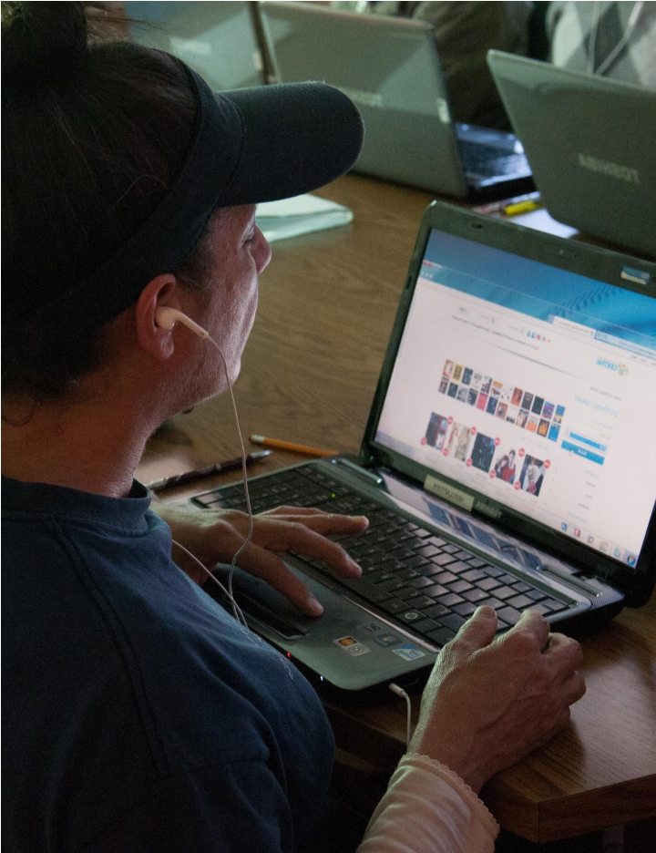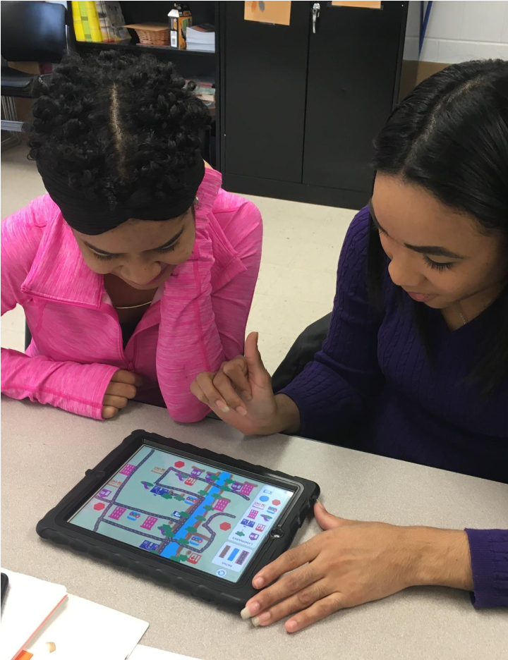

**English for New Bostonians July 2020**

**Developed by:**

**Leah Gregory and Susan Klaw**

**Online Technology Skills**

**for Adult ESOL Students:**

**The Basics**