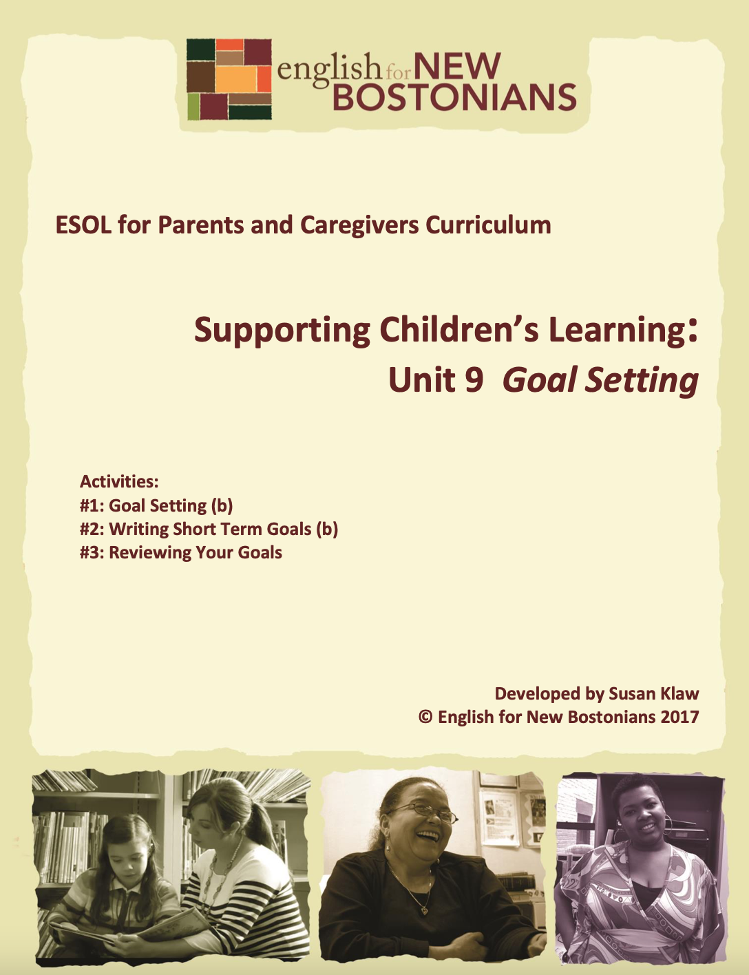About English for New Bostonians
English for New Bostonians (ENB) invests in the future of our region by fostering a high-quality ESOL system that prepares immigrants to pursue their educational, economic and civic aspirations. Through grant making, training teachers, and building public awareness, ENB expands the number of English for Speakers of Other Languages (ESOL) seats, improves program quality across agencies, customizes curricula to diverse subpopulations, and leverages private and public resources. Founded in 2001 by the Mayor’s Office for Immigrant Advancement (MOIA), immigrant leaders, and local foundations, ENB now involves several city departments, approximately 20 public and private funders, and numerous community organizations.

About the ESOL for Parents and Caregivers Initiative
Through ESOL for Parents and Caregivers, ENB guides ESOL providers and immigrant-rich schools in building partnerships to facilitate parent engagement in schools, enabling parents/caregivers to improve their English and digital literacy skills, navigate school systems, and understand expectations and opportunities for school involvement and ways to optimize children’s learning. At the same time, ESOL for Parents helps adults prepare to pursue their own educational and employment goals, while supporting children’s learning – aiming to eliminate multigenerational poverty.

About Susan Klaw
Susan Klaw has directed, taught in, and developed original curriculum materials for Boston-based parent ESOL programs since 1991. She has delivered extensive training locally and nationally on various aspects of Family Literacy and been named a “Literacy Champion” by the Massachusetts Literacy Foundation, Parent Educator of the Year by the Children’s Trust Fund, and Adult Educator of the Year by the Massachusetts Coalition for Adult Education.

About the ESOL for Parents and Caregivers Curriculum
The Curriculum (on ENB website and available free of charge) gives ESOL teachers background materials, lessons and activities designed to help immigrant parents learn English and become more effectively involved in their children’s education. Selecting curriculum units and lessons relevant to their classes, ESOL teachers can orient immigrant parents to the U.S. school system and provide practical skills such as interpreting report cards, participating in teacher conferences, advocating for children, and supporting children's learning at home. While some information is Boston specific, much can be used in any locale. ENB can assist in adapting materials for school districts. Additionally, ENB offers a Companion Middle/High School Guide, as well as a Digital Learning Guide to support online instruction.

Using the ESOL for Parents and Caregivers Curriculum
All materials are intended to be downloaded and widely used. Please cite English for New Bostonians and credit English for New Bostonians on all reproductions. We welcome feedback and stories on how you and your students are using the ESOL for Parents and Caregivers Curriculum!

Thanks to the many public and private funders that have supported this project, especially the Highland Street Foundation, Shipley Foundation, Hamilton Foundation, Moses Kimball Foundation, Plymouth Rock Foundation, Blum Shapiro Foundation and the Mayor’s Office for Immigrant Advancement’s We Are Boston Gala.

Contact us at info@englishfornewbostonians.org
or visit us online at www.englishfornewbostonians.org

Goal Setting: Topic 3 Unit 9 Page 2 ©English for New Bostonians 2017

ACTIVITY #1: GOAL SETTING
(Can be used/adapted for use with beginning level students)
Rationale:
When we articulate goals, it gives us something to strive towards. We make plans about what it will take to achieve the goals. Here students are encouraged to think about the long term goals they have, not only for themselves, but for their children and their families, and to discuss these goals with their children. In Activity #2, they focus on short term, measureable goals they can work on in the coming months.
Note to teachers: Many of the commonly used ESOL textbooks have sections on Goals and Goal Setting. However, the focus is typically on setting goals for oneself while learning goal setting language. We develop targeted materials here because we want our students to think about goals that relate to their children as well as to themselves. If there is a goals unit in the primary textbook being used for the class, by all means combine our unit with those other materials.

Student Objectives:
∙ Students will be able to distinguish between long term and short term goals. ∙ Students will describe in writing their long term goals.
∙ Students will talk to their children about goals for the future.
Materials:
∙ Index cards.
∙ Handout A: Long Term or Short Term Goals?
∙ Handout B: Writing Prompt—My Goals for the Future
Activity Outline:
1. Explain objectives.
2. Opening Discussion: What is a goal? Students may or may not understand this term. A good way to explain goals is to ask students why they are taking the English class. As they answer such things as, “I want to be able to help my children with their homework,” or “I want to get a better job,” point out that these are goals.
3. Hand out index cards. Have everyone write down one goal they have. As they share what they have written, list the goals on the board. Later students will use these goals to distinguish between long term and short term goals.
4. Write on an easel pad and teach basic goal related expressions students will use in this unit. Save the sheet for review as students do future goal related activities.
Goal Setting: Topic 3 Unit 9 Page 3 ©English for New Bostonians 2017

∙ Long term goal
∙ Short term goal (define it as a goal you can reach within 6 months or before the end of the school year)
∙ Measureable goal
∙ To meet, (to reach, to accomplish) a goal
∙ To work on a goal
∙ Realistic goal
5. Review the list of student goals on the board. As you read each one, ask students to decide whether it is a long term or a short term goal.
6. Cut up into strips the goals from the Handout A: Long Term or Short Term Goals? and put them into a basket. Have students take turns drawing a strip, reading it aloud and saying whether it is a long term or short term goal. Make sure there is at least one strip for each student, writing additional ones if you need to. Short term goals should be reachable within a specified period of time, for example six months.
7. Distribute the Handout B: Writing Prompt—My Goals for the Future. Ask students to write about their long term goals for themselves, their families and their children. If they have already written something about their dreams, perhaps in connection with Martin Luther King Day, refer back to that and point out that dreams and long term goals are similar. One can say “My dream is to become a citizen,” or “My long term goal is to become a citizen,” and the meanings are similar. A dream is something you hope will happen. A goal is something you work on to make happen. Intermediate level students should be asked to write a paragraph. Beginning students can write goals as a list. You might want to slowly read aloud the writing prompt, telling students to close their eyes and visualize themselves in the future.
8. When first drafts have been revised and rewritten, invite students to read their essays (lists) aloud to their classmates. A good way to do this is to have the student who is reading stand in the front of the room. Make sure everyone claps when they finish reading.
9. Family Homework: Have students share and talk about their essays with their children. Have them ask their children about their goals (dreams) for the future. Older children can write these goals down themselves. Younger ones can be encouraged to draw a picture of one of their goals. The next class, students report back on the conversations they had with their children about goals and dreams. They share what their children wrote and show the drawings they did.
10. Summary discussion question: Is it important to have goals? Why? Write student reasons on the board.
Goal Setting: Topic 3 Unit 9 Page 4 ©English for New Bostonians 2017

Handout A: Long Term or Short Term Goals?
You are a Boston parent with a 3rd grader. One of your goals is to go to the library every week until the end of school.

You are from Columbia. Your mother still lives there. Your goal is to one day buy a house in your country that she will live in.

You have children in kindergarten and 4th grade. One of your goals is for your children to go to college.

You have a 2nd grader who is having difficulty with reading and spelling. One of your goals is to talk to your child’s teacher every week to see how she is doing.

You are from Ethiopia. You came here one year ago. One of your goals is to get your citizenship.

Your son is starting middle school in three months. You know that he will need a computer for many of his homework assignments. Your goal is to buy a computer.

You have three children. As soon as they get home from school and do their homework, they start watching TV. Your goal is to limit TV to one hour a day.

You have a new job and will be working this summer. Your goal is to find a good summer camp program for your daughter who is 9 years old.
Goal Setting: Topic 3 Unit 9 Page 5 ©English for New Bostonians 2017
Your goal is to get your GED. You know that first you need to improve your English.

Your son who is four just got into a K1 classroom. Your goal is to teach him his letters and numbers before he starts.

Your goal is to move back to Mexico when your children are grown up.

You want to learn more about computers. Your goal is to take the computer class at the library.

Goal Setting: Topic 3 Unit 9 Page 6 ©English for New Bostonians 2017

Handout B: Writing About Your Goals for the Future
Directions: Close your eyes and think about the future. Imagine it is 10 years from now. What would you like to be doing? Where will you and your family be? What will your children be doing? Now write about your long term goals or dreams for yourself, your family and your children.

__________________________________________________________________________________________________ __________________________________________________________________________________________________ __________________________________________________________________________________________________ __________________________________________________________________________________________________ __________________________________________________________________________________________________ __________________________________________________________________________________________________ __________________________________________________________________________________________________ __________________________________________________________________________________________________ __________________________________________________________________________________________________ __________________________________________________________________________________________________ __________________________________________________________________________________________________ __________________________________________________________________________________________________ __________________________________________________________________________________________________ __________________________________________________________________________________________________
Goal Setting: Topic 3 Unit 9 Page 7 ©English for New Bostonians 2017

ACTIVITY #2: DEVELOPING SHORT TERM GOALS
(Can be used/adapted for use with beginning level students)
Rationale:
Setting and working towards measureable goals gives students and their children a sense of accomplishment.
Student Objectives:
∙ Students will be able to set short term, measureable goals for themselves which will promote family learning.
∙ Students will help their children set goals for the school year.
Materials:
∙ Handout A: Measureable Short Term Goals?
∙ Handout B: How Do You Turn These Short Term Goals into Measureable Goals? ∙ Handout C: My Goals
∙ Handout D: Goal Examples
∙ Handout E: Talking About Goals with my Children
Activity Outline:
1. Explain objectives.
2. Warm up and review: Review the difference between long term and short term goals as well as other goal related vocabulary from the previous exercise. Explain that while the previous activity focused on long term goals, this activity will focus on short term goals, e.g. goals students plan to work on and reach within the program year. Illustrate on the board the difference between a general and a specific, measureable, goal, by making a chart like the one below. Or copy this one to hand out.
General Short Term Goals | Measureable Short Term Goals
To lose weight | To lose 1 lb. a week
To talk more to my son’s teacher | To talk to my son’s teacher once a month
To eat more fruits and vegetables | To eat at least one vegetable and one fruit every day
To go to the library more | To go to the library every two weeks

Ask students if they think it is easier to work on a general short term goal or a measureable short term goal, and why.
Goal Setting: Topic 3 Unit 9 Page 8 ©English for New Bostonians 2017
3. For practice in indentifying and forming measureable goals, make goal strips from the Handout A: Measureable Short Term Goals? Put the strips in a basket. Have students take turns drawing a strip, reading it aloud and saying whether it is a
measureable goal. If it isn’t a measureable goal, demonstrate to the group how you can re-state the goal, making it measureable, by adding a quantifier, such as “every week,” or “by January 1.” Make sure there are enough strips so that each student gets a chance. Write additional ones if necessary.
4. Use Handout B: How Do You Turn These Short Term Goals Into Measureable Goals to give students additional practice in making goals more specific. Their task is to add a specific time frame to each of the goals. Do the first one together as an example.
5. With intermediate students, give them additional writing practice by handing out index cards and asking them to write one measureable, short term goal. It should be a goal they actually have for themselves. Point out that in writing measureable goals, you have to first think about what you have done in the past. For example:
If your goal is to go to the library more often, think about how often you went to the library in the last year. If you went every month, then a realistic goal is to go every two weeks. However, if you only went to the library once in the last year, then it would be more realistic to set a goal of going to the library once a month.
6. Circulate to help students write measureable goals.
7. Ask students to read their completed goals. After each goal is read, ask the group whether it is a measureable goal. Ask the student whether he or she can reach that goal within six months. If it is not a measureable goal, ask for suggestions on how it can be revised.
8. Distribute Handout C: My Goals and read over the form together, giving or asking for examples as you go through it. Stress that the goals they write should be goals they actually want to work on and meet while they are in the program.
9. Decide whether you want to use Handout D: Goal Examples. It serves as a menu of possible goals. The advantage of using it is to suggest to students a range of goal possibilities. The disadvantage is that some students may just copy a goal that really isn’t their goal. One way to use the goal examples would be to give it out only if a student appears to be having trouble developing a goal in a particular category.
10. Give students plenty of time to think about and write their goals. This first draft could also be given as a homework assignment. Collect the goals and make grammatical corrections. Conference with students individually to clarify meaning and to help make the goals measureable.
Goal Setting: Topic 3 Unit 9 Page 9 ©English for New Bostonians 2017

11. Give students a new blank Goals form, this time with the directions eliminated, and have them neatly recopy their goals. Alternatively, type the goals for them to create a nicely finished product.
12. Create several additional copies of each set of student goals. If possible, copy them onto brightly colored card stock and laminate them. Give students a nice copy to post at home and/or one to attach to the front of their notebooks with packing tape. The point is for the goals to be visible to the students. Keep copies for yourself in a folder. These will be useful for subsequent goal reviewing activities if students don’t have their goals with them in class.
13. Family Homework: Distribute the Handout D: Talking About Goals With my Children and go over the assignment. Tell students that in the next class, they will share their children’s goals.
14. Summary: Tell students that they will review their goals monthly in class to track progress on meeting the goals.
Goal Setting: Topic 3 Unit 9 Page 10 ©English for New Bostonians 2017

Handout A: Measureable Short Term Goals?
To go to the preschool story hour at the library every week until the end of school.

To check my child’s backpack more often for school notices and homework.

To read to my child at home.

To get more exercise.

To get my driver’s license by the beginning of the summer so I can help drive when we go on a family vacation.

To save $50 a week so I can go visit my country this summer.

To learn about the Head Start program in my neighborhood.

To ask my child every day about school and what she learned.

To attend the weekly parent breakfast 75% of the time.

To watch television in English to improve my English.

Goal Setting: Topic 3 Unit 9 Page 11 ©English for New Bostonians 2017
To talk to my neighbors in English every time I see them.

To enroll my daughter in Arabic class.

Goal Setting: Topic 3 Unit 9 Page 12 ©English for New Bostonians 2017

Handout B: How Do You Turn These Short Term Goals
Into Measureable Goals?
Directions: Rewrite the following goals so that they become measureable goals.
To go to the preschool story hour at the library.

To check my child’s backpack more often for school notices and homework.

To read to my child at home.

To get more exercise.

To get my driver’s license so I can help drive when we go on a family vacation.

To save money so I can go visit my country this summer.

To learn about the Head Start program in my neighborhood.

To ask my child about school and what she learned.

Goal Setting: Topic 3 Unit 9 Page 13 ©English for New Bostonians 2017
Handout C: My Goals
Name: ____________________________
Note: Remember, these are short term goals which you plan to meet by the end of the school year. And remember to make goals measureable. For example, say “I will talk to my son’s teacher once a month” rather than “I will talk more often to my son’s teacher.”

Type of Goal | Goal
Personal Goals | 1.  2.
Family Learning Goals ( things I will do with my children that will help them learn and be good  students) | 1.  2.
School  involvement  goals (things I  will do to be  more connected to my child’s  school) | 1.  2.
Parenting Goals (things I will do to help my  children grow  and develop) | 1.  2.

Goal Setting: Topic 3 Unit 9 Page 14 ©English for New Bostonians 2017
Handout D: Goal Examples
Personal Goals - Examples of what parents wrote in past years
∙ Register to vote
∙ Save money to go to my country over the summer
∙ Learn to use the internet
∙ Take citizenship classes
∙ Find a part time job in the morning
Family Learning Goals - Examples of what parents wrote in past years ∙ Go to the library every week
∙ Go to the pre-school story hour at the library
∙ Go to the children’s museum with my family at least two times ∙ Read with my children every day for at least 20 minutes
∙ Limit television watching
∙ Help my son learn his letters and numbers
∙ Buy puzzles and games for Christmas presents
∙ Buy books for my daughter’s birthday present
∙ Be in the parent/child computer class
∙ Plan special activities for school vacation weeks
∙ Sign my child up for the City Year camp during school vacation weeks ∙ Tell my child stories about my childhood
∙ Teach my child how to read in Spanish (Portuguese, Arabic) ∙ Teach my child how to write in Spanish (Portuguese, Arabic) ∙ Eat dinner together every night
∙ Have a special family night once a week
∙ Take books with us to read when we go to the clinic and have to wait ∙ Buy a computer for the house
School Involvement Goals - Examples of what parents wrote in past years ∙ Attend the parent breakfast every week
∙ Join the school site council
∙ Talk to my children’s teachers at least once a week
∙ Have at least two parent conferences during the year
∙ Visit my child’s class at least once
∙ Go on field trips with my daughter’s class
∙ Check my child’s backpack every day for school notices. Read those notices ∙ Ask my child about school every day
∙ Help my child with his homework every day
Goal Setting: Topic 3 Unit 9 Page 15 ©English for New Bostonians 2017
Parenting Goals- Examples of what parents wrote in past years
∙ Help my child learn to dress himself
∙ Teach my child how to help with household chores.
∙ Encourage my child to express his/her feelings
∙ Encourage my child to express his/her opinions
∙ Limit television
∙ Arrange for my child to play with other children from school on the weekends ∙ Sign up my child for swimming lessons
∙ Sign up my child for music lessons
∙ Help my child get more exercise
∙ Register my child for preschool
Goal Setting: Topic 3 Unit 9 Page 16 ©English for New Bostonians 2017

Handout E: Talking About Goals with my Children
Explain to your children what goals are. Talk to them about goals they have for this school year. You could also share the goals you wrote with them. Encourage them to think about something in school they want to improve and something outside of school they want to do. You can talk to them in any language you want, but together write down what they say in English. Bring back this paper to share in class.
Goals I have for school this year:
1. I want to __________________________________________________________
2. I want to __________________________________________________________
3. I want to __________________________________________________________
Goals I have for outside of school this year:
1. I want to __________________________________________________________
2. I want to __________________________________________________________
3. I want to __________________________________________________________
Goal Setting: Topic 3 Unit 9 Page 17 ©English for New Bostonians 2017

ACTIVITY #3: REVIEWING YOUR GOALS
Rationale:
Having students review their goals on a monthly basis in class helps them keep focused on what they want to accomplish and provides opportunities for language development.
Student Objectives:
∙ Students will review and work on their goals throughout the school year. ∙ Students will be able to develop action steps connected to their goals. ∙ Students will be able to use goal related vocabulary to describe their progress.
Materials:
∙ Handout: Action Steps
Activity Outline: Ways to Review Goals in Class:
It is recommended that student goals are reviewed on a monthly basis. Below are several different ways to review goals that simultaneously build language skills.
1) Writing Action Steps:
Review goal related vocabulary from Activity #1. Using the Handout: Action Steps, add a new concept, that of action steps. These are the different things you need to do, in sequence, if you want to meet a goal. Have students complete the handout as directed and show you their plans when they have finished. This activity can be repeated, with students choose a different goal each time to devise action steps for.
2) Telling Your Partner:
Review goal related vocabulary from Activity #1. Have students review their goals. Divide students into pairs or have them choose a partner. With the first partners, students tell each other about a goal they have met and how they met it. Then change partners. With the second partner, students will tell each other about a goal they have not yet met. Perhaps they are working on it, or perhaps the goal has changed.
3) Dice Game:
Review goal related vocabulary from Activity #1. Divide students into small groups and give each group a set of dice. Go over the concept of even numbers and odd numbers. The directions for the game are: Take turns rolling the dice. If you get an even number, tell your group about a goal you have met. If you get an add number, tell your group about a goal you are still working on.
4) Game: Whose Goal Is It?
From your saved copies of student goals, choose goals which are fairly distinct. Read those aloud and have students guess which of their classmates wrote that goal.
Goal Setting: Topic 3 Unit 9 Page 18 ©English for New Bostonians 2017
5) Goal Bulletin Board:
Give students extra copies of their goal forms. Ask them to review their goals and circle the one that is most important to them. Have them go around and share their choices and then hand in the papers. Create an Our Goals bulletin board with those goals quoted with perhaps an accompanying picture of the student.
Follow-Up:
∙ Have students do an end of the year essay titled “My Accomplishments”. Encourage them to include as accomplishments goals they set and met. Use these essays for end of the year ceremonies and booklets of student writing.
Goal Setting: Topic 3 Unit 9 Page 19 ©English for New Bostonians 2017

Handout: Action Steps
In order to meet a goal, you usually have to do a series of things in a certain order. These are called action steps.
For example, if your goal is to buy a house, your action steps might be: 1--save money until I have at least $5000 for a down payment.
2--attend the first time home owner class at the library
3--talk to other friends and relatives who have recently bought houses
4--find a good real estate agent
Directions: Choose one of the goals you have written. Copy it. Describe what action steps you need to take to help you reach your goal.

Goal: _________________________________________________
Action steps to reach my goal:
1.________________________________________________
2._______________________________________________
3._______________________________________________
Show a partner what you have written. Ask your partner to suggest one other action step that will help you reach your goal.
Write down what your partner suggested:
________________________________________________________________________________________________ Show the teacher your goal and your action steps.
Goal Setting: Topic 3 Unit 9 Page 20 ©English for New Bostonians 2017

