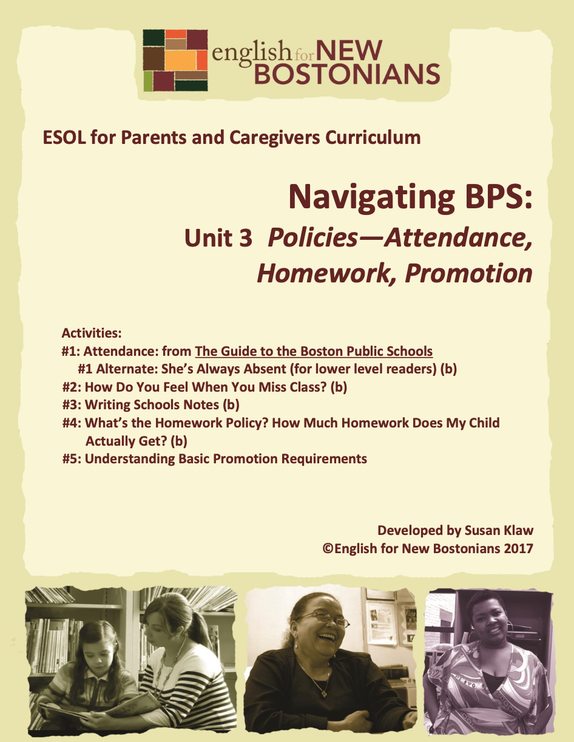
Developed by Susan Klaw
© English for New Bostonians 2022

About English for New Bostonians
English for New Bostonians (ENB) invests in the future of our region by fostering a high-quality ESOL system that prepares immigrants to pursue their educational, economic and civic aspirations. Through grant making, training teachers, and building public awareness, ENB expands the number of English for Speakers of Other Languages (ESOL) seats, improves program quality across agencies, customizes curricula to diverse subpopulations, and leverages private and public resources. Founded in 2001 by the Mayor’s Office for Immigrant Advancement (MOIA), immigrant leaders, and local foundations, ENB now involves several city departments, approximately 20 public and private funders, and numerous community organizations.

About the ESOL for Parents and Caregivers Initiative
Through ESOL for Parents and Caregivers, ENB guides ESOL providers and immigrant-rich schools in building partnerships to facilitate parent engagement in schools, enabling parents/caregivers to improve their English and digital literacy skills, navigate school systems, and understand expectations and opportunities for school involvement and ways to optimize children’s learning. At the same time, ESOL for Parents helps adults prepare to pursue their own educational and employment goals, while supporting children’s learning – aiming to eliminate multigenerational poverty.

About Susan Klaw
Susan Klaw has directed, taught in, and developed original curriculum materials for Boston-based parent ESOL programs since 1991. She has delivered extensive training locally and nationally on various aspects of Family Literacy and been named a “Literacy Champion” by the Massachusetts Literacy Foundation, Parent Educator of the Year by the Children’s Trust Fund, and Adult Educator of the Year by the Massachusetts Coalition for Adult Education.

About the ESOL for Parents and Caregivers Curriculum
The Curriculum (on ENB website and available free of charge) gives ESOL teachers background materials, lessons and activities designed to help immigrant parents learn English and become more effectively involved in their children’s education. Selecting curriculum units and lessons relevant to their classes, ESOL teachers can orient immigrant parents to the U.S. school system and provide practical skills such as interpreting report cards, participating in teacher conferences, advocating for children, and supporting children's learning at home. While some information is Boston specific, much can be used in any locale. ENB can assist in adapting materials for school districts. Additionally, ENB offers a Companion Middle/High School Guide, as well as a Digital Learning Guide to support online instruction.

Using the ESOL for Parents and Caregivers Curriculum
All materials are intended to be downloaded and widely used. Please cite English for New Bostonians and credit English for New Bostonians on all reproductions. We welcome feedback and stories on how you and your students are using the ESOL for Parents and Caregivers Curriculum!

Thanks to the many public and private funders that have supported this project, especially the Highland Street Foundation, Shipley Foundation, Hamilton Foundation, Moses Kimball Foundation, Plymouth Rock Foundation, Blum Shapiro Foundation and the Mayor’s Office for Immigrant Advancement’s We Are Boston Gala.

Contact us at info@englishfornewbostonians.org
or visit us online at www.englishfornewbostonians.org

ACTIVITY #1: READING THE PAGE ON ATTENDANCE FROM THE GUIDE TO THE BOSTON PUBLIC SCHOOLS
Rationale:
Being in school every day, on time, is a child’s job. Parents need to understand how important good attendance is and the consequences for children if they miss a lot of school.
Student Objectives:
▪ Students will understand the consequences if their children are absent ▪ Students will learn what BPS considers an excused absence and an unexcused absence.
▪ Students will practice getting information out of difficult texts.
Materials:
▪ Current Guide to Boston Public Schools for Families and Students, “Promotion Policy and School Attendance.” Hard copies are available at most schools and at the BPS Welcome Centers. Parents receive copies of the guide at the beginning of the school year. If you do not have a hard copy of the Guide, you can download the page. Go to the BPS website and searh for the Guide.
▪ Handout: Attendance Policy Case Studies
Activity Outline:
1. Explain objectives.
2. Opening discussion: When you went to school in your country, what happened if you missed school? Why is it important to be in school as much as possible? Explain that BPS has strict attendance policies.
3. Create columns on the board with Excused Absence and Unexcused Absence as headings. Define the words. Ask students to list what they think are examples of either kinds of absences and write those down.
4. Hand out the Promotion Policy and School Attendance page from the current Guide. Show students a hard copy of the Guide so those who are BPS parents will recognize it as a booklet they received (but probably didn’t read) at the beginning of the school year. Ask: How many of you have this Guide? How many of you have it in your first language? Who read it? Remind them that it contains a lot of information about the Boston schools and is good to have as a reference.

5. Help students learn how to decipher texts by reading the headings. What’s this page about? Where you can you find information on excused absences? On unexcused absences?
6. Read the BPS list of excused and unexcused absences aloud with students, clarifying terms when necessary. Then go back to the examples students generated in Step 3. Read each one and ask, Were we correct? Is this excused or unexcused?
7. Show students a sample BPS report card (School Involvement-Unit 3-Report Cards, Activity #1). The absences listed on the report card are unexcused absences. If the parent thinks that number is wrong when s/he gets the report card, s/he should go into the school office to discuss it.
8. Give out the Handout: Attendance Policy Case Studies. This is a way for students to digest the above information. Read the case studies aloud and do them as a group, or have students read them individually.
Follow-Up:
If students haven’t read the handout The Flores Family goes to El Salvador at Christmas: A True Story, this would be a good place to include it (Topic 1: Unit 1: Activity #6.) If students have read it, reference it.
\

Handout: Attendance Policy Case Studies
Jose is in 4th grade. In September he missed two days of school because he had an ear infection. In October, he didn’t miss any days of school. In November, he missed two days of school before Thanksgiving because his family went to visit relatives in New York.
How many unexcused absences will he have for the first marking period? ___
Amalia is in 8th grade. She missed a week of school in May because her four year old brother was sick and her mother needed her to babysit while she went to work.
How many unexcused absences will she have for the last marking period?_____
Victor is in 2nd grade. In February he missed four days of school because he had a bad asthma attack. When he returned to school, his mother sent in a note from the doctor who had seen him in the emergency room of Boston Medical Center.
How many unexcused absences will he have for the second marking period?_____

ACTIVITY #1 ALTERNATE: SHE’S ALWAYS ABSENT (FOR LOWER LEVEL READERS)
Rationale:
The BPS Guide to the Boston Public Schools for Families and Students is too difficult to read in English for Level 1 ESOL students. This reading passage provides an alternative or additional way to read and discuss attendance.
Student Objectives:
▪ Students will understand acceptable and unacceptable reasons for being absent from school.
▪ Students will read and understand a passage about school attendance.
Materials:
▪ Current Guide to Boston Public Schools for Families and Students, “Promotion Policy and School Attendance.” Hard copies are available at most schools and at the Welcome Centers. Parents receive copies of the Guide at the beginning of the school year. If you do not have a hard copy of the Guide, you can download the page. Go to the BPS website and search for the Guide.

▪ From Home to School 2, Ann Gianola, New Readers Press, 2003, Lesson 15: She’s Always Absent.
Activity Outline:
1. Explain objectives.
2. Do Lesson 15, She’s Always Absent, from the textbook Home to School 2.
3. Make a simplified chart for students of BPS Excused and Unexcused Absences. Go over each item on the list to clarify.
Follow-Up:
▪ If students haven’t read the handout The Flores Family goes to El Salvador at Christmas: A True Story, this would be a good place to include it. It is in Topic 1: Unit 1: Activity #6. If students have read it, reference it.

ACTIVITY #2: HOW DO YOU FEEL WHEN YOU MISS CLASS?
(Can be used/adapted for use with beginning level students)
Rationale:
When parents make connections between their own learning experiences and those of their children, it helps them support their children’s learning and further motivates them in reaching their own goals.
Student Objectives:
▪ Students will be able to talk about how they feel and how their children feel when they miss school.
▪ Students will learn adjectives that describe feelings.
Materials:
Activity Outline:
1. Explain objectives.
2. Write the following key “feeling” adjectives on the board. Ask students for suggestions of additional adjectives. Clarify meanings by giving examples of how one feels in different situations. Have students give examples too: When do you feel proud of your children? Do you ever feel shy?

embarrassed proud
ashamed excited
confused confident
shy talkative
discouraged encouraged
3. Have students complete the following sentences:
When I miss my English classes, I feel ________________________.
When my child misses school, they feel _______________________.
4. Ask students to share and discuss what they wrote with a partner, then ask for volunteers to share what they wrote.
5. Write on the board and explain the following key phrases:
fall behind
catch up
make-up work

6. Write: When you miss a lot of classes, you fall behind and it is hard to catch up. Ask for a show of hands: Who agrees with this statement? Who disagrees with this statement?
7. Do a group brainstorm: What can you do to help your child catch up when your child misses school? Suggest or reinforce the idea that if your child is going to be out of school for a couple of days, you can ask the teacher for make-up work and homework and have the child do it at home.
Follow-up:
▪ Have students set attendance goals for themselves for the next month.
▪ Have students write a paragraph for homework explaining how they feel when they miss classes
▪ Adjective Bingo Board: For further feeling adjectives practice, create an Adjective Bingo Board. This Bingo Board technique is adapted from Zero Prep, Ready to go Activities for the Language Classroom, by Laurel Pollard and Natalie Hess, 1997. Write the adjectives used in this activity on the board and add to them. Have students draw a 3 x 3 grid on a piece of paper. Instruct them to fill their squares with adjectives form the board, taken at a random order. Give them something to mark their bingo squares with (dried beans, paper clips, pennies). Call out the adjectives. If a student has one on their board, the student covers that square. Three covered squares in a row is a Bingo. When a student gets Bingo, they are not automatically the winner. The student must use each of the adjectives comprising the Bingo in a sentence such as “I feel _______________ when I _______________________________. If they don’t use it correctly, the game continues until there is another bingo. You can also play the game with 4 X4 squares.

ACTIVITY #3: WRITING SCHOOL NOTES
(Can be used/adapted for use with beginning level students)
Rationale:
This authentic writing activity was developed because of a student request. A mother wanted to know how to write the BPS required absence notes in good English, even though her daughter’s teacher spoke and read Portuguese.
Student Objectives:
▪ Students will learn how to write required school notes when their child is absent.
▪ Students will review what is an excused and what is an unexcused absence.
▪ Students will learn the format for writing a note.
Materials:
▪ Handout: Absences: Writing School Notes
▪ Copies of any letters schools may have sent to parents re their Attendance Policy Activity Outline:
1. Explain objectives.
2. Distribute Handout Absences: Writing School Notes. Explain that parents must send in notes to school with their children after their children have been absent if they want the absence to be excused. Sometimes parents say “Well, I just text my child’s teacher if he is sick.” In general, a text does not constitute the record teachers need to change an absence from unexcused to excused. Review what needs to be included in the note to teacher. Review the format for writing a letter.
3. Make a list of key childhood illness related words on the board. Have parents practice pronouncing the words and then have them copy down the list.
Diarrhea Vomiting
Fever Stomach Ache
Ear Infection Sore throat
Cough Asthma
Cold Flu
4. Have students write their sample notes. Circulate to help and correct. Have students read their notes aloud to the class. Suggest that students save their notes as a model to use in the future.
5. Homework: have students write two absence notes to their child’s teacher. Write the notes on two different sheets of paper. One should be for an absence that will be

excused. One should be for an absence that will not be excused. Explain that you will play a guessing game with these notes in the next class.
6. Collect the notes students have written, put them in a box and shuffle them around. Pull out a note and read it aloud. Students have to guess whether this is an excused or unexcused absence and explain their reasoning.
Follow-Up:
▪ Have students write and receive help with other authentic notes in class: thank you notes, appreciation notes, holiday cards, sympathy notes.

▪ Have students practice writing absence notes by writing them to you, explaining their own absences.

Handout: Absences: Writing School Notes
When your child is absent from school you must write a note to the teacher and send it in when your child returns to school. The note should include:
- Your child’s name
- The dates your child was absent
- The reason your child was absent
- A doctor’s note if your child was out sick for more than two days.
- Your signature and a phone number
Here is a sample note:
February 8, 2012
Dear Ms. Perez,
My daughter, Andrea Vazquez, was home because she was sick on February 6 and February 7. She had a bad cold (upset stomach, headache, asthma). Please excuse her absences.
Sincerely,
Maria Vazquez 617 313 1311

Now you practice:
Situation: Your daughter (or son) was out sick for two days because she had a fever.
Directions: Write a note for your child to take to the teacher when returning to school. Copy the sample. Use your real name and your child’s real name.

ACTIVITY #4: WHAT’S THE HOMEWORK POLICY? HOW MUCH HOMEWORK DOES MY CHILD ACTUALLY GET?
(Can be used/adapted for use with beginning level students)
Rationale:
Parents understand that monitoring homework is a primary parental responsibility. In elementary school based ESOL classes, “Being able to help my child with homework” is the number one reason students give for joining the class. Understanding the BPS policy versus their child’s actual experience helps parents learn how to advocate for their children.
Student Objectives:
∙ Students will understand how much homework BPS says their children should get and what to do if that if that isn’t happening.
∙ Students will be able to compare a written policy with their own experience.
Materials:
▪ Current Guide to Boston Public Schools for Families and Students, “Homework Recommendations”. Hard copies are available at most schools and at the BPS Welcome Centers. Parents receive copies of the Guide at the beginning of the school year. If you do not have a hard copy of the Guide, you can download the page. Go to the BPS website and search for the Guide.
▪ Handout: My Child’s Experience with Homework
Activity Outline:
1. Explain objectives.
2 Opening discussion questions: Why do teachers give homework? How much homework do you think children should get? List responses on the board.
3. Have students in partners discuss these questions:
∙ When you were in elementary school, did you have homework?
∙ Did you have homework every day?
∙ What did you have to do for homework?
Ask students to report back to the group what their partner said.
4. Distribute and have students fill out the handout: My Child’s Experience with Homework

5. Read together the section on homework recommendations for elementary school from the Guide. Compare the reasons given by BPS for homework with those students listed themselves. Compare recommended homework time with what students thought. Point out that the amount of homework goes up as children get older. BPS recommends 30-60 minutes per day for elementary school,
2 hours for middle school and 2 ½ hours for high school. If many students in the class have children in middle school or high school, then do the same activity below and use those recommended times.
6. Have parents look back at the handout they filled out to consider whether their child’s actual experience matches BPS policy. Do a Vote with your feet activity. Write these three statements on paper and post them in different corners of the room:
∙ My child gets 30-60 minutes of homework per day.
∙ My child gets less than 30 minutes of homework per day.
∙ My child gets more than 60 minutes of homework per day.
Ask students to go stand under the statement that matches their child’s experience.
7. Have those students whose children either get too little or too much homework to elaborate. Ask whether it bothers them. If it does, have the class help problem solve. What should this parent do? Talking to the child’s teacher is the answer you are looking for. If a child isn’t getting much homework, the teacher should be asked to explain her homework system. The parent can refer to the page in the Guide. If the parent continues to worry because her child gets too little homework, she should arrange to talk to the Principal. If a child is spending too long doing homework every night, the parent should also meet with the teacher and work out a different homework plan for that child. Unless a parent tells them, a teacher has no way of knowing if a child is struggling far too long to complete homework assignments.
Follow-up:
▪ Go to Topic 3: Supporting Children’s Learning, Unit 4: Homework, for important additional activities on the topic of homework. Because children do homework throughout the entire year and parents are responsible for monitoring that process, it is recommended that the homework unit be done no later than half way through the school year. January would be ideal.
▪ For those students who have children in middle and high school, they could look at the homework recommendations for those age groups on pages 20 and 22 in the Guide. Encourage any concerned parents to meet with their child’s teacher and ask them to report back to the group on the meeting
▪ College Talk: Take a moment to explain to students how most of the work you do in college is homework, or independent work. You are expected to do approximately 10 hours per week of independent work for each course you are taking. A full time student usually takes four courses a semester. Homework in elementary, middle and high school teaches students how to learn independently. This is something they need to be able to do to succeed in college.

Handout: My Child’s Experience with Homework
My child is in _______________________ grade.

My child gets homework (every day, 3-4 times a week, once a week, never).
Circle one

It usually takes my child _______________________ do to the homework.
Amount of time
The homework is usually (too hard, just right, too easy) for my child. (Circle one)
If you have more than one child in school, complete the same sentences for your second child.
My child is in _______________________ grade.

My child gets homework (every day, 3-4 times a week, once a week, never).
Circle one

It usually takes my child _______________________ do to the homework.
Amount of time
The homework is usually (too hard, just right, too easy) for my child. (Circle one)

ACTIVITY #5: UNDERSTANDING BASIC PROMOTION REQUIREMENTS
Rationale:
BPS promotion requirements as presented in the Guide to the Boston Public Schools for Families and Students are complex. However parents in an ESOL setting can gain a basic understanding through learning key vocabulary and focusing on what their children will need to do to be promoted from their current grade.
Student Objectives:
▪ Students will understand what their children have to do to be promoted.
▪ Students will learn new vocabulary related to promotion and retention.
Materials:
▪ Current Guide to Boston Public Schools for Families and Students, “ Promotion Requirements.”Hard copies are available at most schools and at the BPS Welcome Centers. Parents receive copies of the Guide at the beginning of the school year. If you do not have a hard copy of the Guide, you can download the page. Go to the BPS website and search for the Guide.
▪ Handout: Practice With Words Related to Promotion
▪ Handout: Promotion Worksheet
Activity Outline:
1. Explain objectives.
2. Write key promotion related terms, phrases and abbreviations on board and explain.
▪ promotion/promote
▪ retain/repeat a grade
▪ take a course
▪ pass a course
▪ passing grade
▪ requirement
▪ ELA
▪ ESL
3. Distribute Handout: Practice With Words Related to Promotion for students to complete. Have students do peer correction with their dialogue reading partner.

4. Handout copies of pages from the Guide which summarize BPS promotion requirements for elementary school and middle school students (the high school promotion information is too complicated).
5. Ask students to find and read promotion requirements for their own child, this year. Have students complete the Handout: Promotion Worksheet to help them digest the information. Circulate to help and to answer individual questions.
Follow-Up:
Invite a school administrator or teacher in to the class to talk about how decisions are made about promotion and retention.

Handout: Practice With Words Related to Promotion

New words and phrases
promotion/promote retain/repeat a grade
take a course pass a course
passing grade requirement
ELA ESL

1. Read the paragraph below and underline new words and phrases that relate to promotion.
Susana’s son Daniel is in 1st grade. His teacher had a conference with Susana last week to explain to Susana that she thought Daniel should repeat 1st grade. She said he wouldn’t get a passing grade in either ELA or mathematics. The teacher told Susana that Daniel was one of the youngest boys in the class and that was why he was having trouble with ELA. She said that if she retained him, she was sure he would meet all the requirements the following year.
2. Underline the correct meaning for the sentences:
He was promoted at the end of 2nd grade.
▪ Moved to the next higher grade
▪ Told he would have to repeat 2nd grade
She passed all her courses in 8th grade.
▪ She did not do well in her courses.
▪ She got a passing grade in all her courses.
He was retained at the end of 2nd grade.
▪ He had to repeat 2nd grade.
▪ He had to go to another school.
Passing the MCAS is not a requirement for promotion in elementary school.
▪ You do have to pass MCAS to be promoted in elementary school.
▪ You do not have to pass the MCAS to be promoted in elementary school

3. Practice the following dialogue with a partner. Read it several times. Change roles.
Teacher: Hi, Mrs. Flores. Thank you for coming in. I want to talk to you about your daughter Teresa.
Parent: Is anything wrong?
Teacher: She is still having trouble with math. You saw on the last report card that she didn’t pass math.
Parent: Does that mean she won’t be promoted?
Teacher: She is going to be required to go to a Summer Learning Academy. If she gets a passing grade in math in summer school, then she won’t be retained.
Parent: So then after summer school will she be promoted to 4th grade? Teacher: Yes, if she passes math, which I’m sure she will with a little extra help.

Handout: Promotion Worksheet
My child is in _________grade. For my child to be promoted in June, my child must pass the following subjects:
_________________________________
_________________________________
_________________________________
_________________________________
_________________________________

